**Results**

**1. Applying walkability indices**

* Result of Objective 2

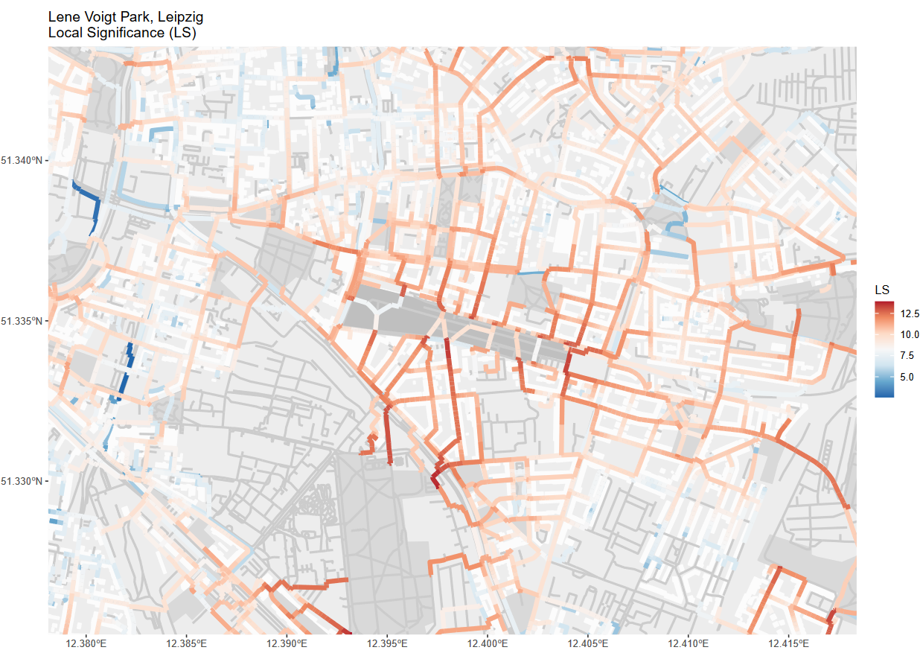

*Figure 2: The network colors depict the cumulative Local Significance index (LS). A higher LS value is depicted by a darker red color, representing i.) more people taking this path, ii.) the people taking this path are living in closer proximity to the green space, and / or iii.) the path is leading to a larger green space. Since the LS values are cumulative, a higher value might also mean more paths from different buildings overlapping (See Appendix … for further information).*

* City scenarios
  + Base indicators
    - Figure X displays the local significance (LS) values that we calculated for the city of Leipzig, Germany.
  + (Map description (leave here or Appendix?))
    - The map shows the area east of the city center (top right corner of the map).
    - In the center of the map, highlighted with a darker gray, is located the Leve-Voigt-Park (LVP).
    - Other green spaces are depicted in a lighter gray, buildings and the network in white and gray, respectively.
    - Lower LS values are displayed in blue shades, higher values in red shades.
    - Due to the high density of green spaces and residential buildings in the area, an overall high level of LS values can be observed.
    - Especially high LS values occur in close proximity to the LVP.
    - The highest values can be found at park entries adjacent to streets which connect the LVP to areas with high population.
    - The eastern part of the LVP close to the *Riebeckestraße* is a good example for this.
    - Here, we find high LS values at those parts of the streets that lead to the residential areas in the north, east and south-east.
    - Likewise, the *Josephinenstraße* which connects the center of the LVP to the next larger park in the south, the *Friedenspark*, displays high LS values.

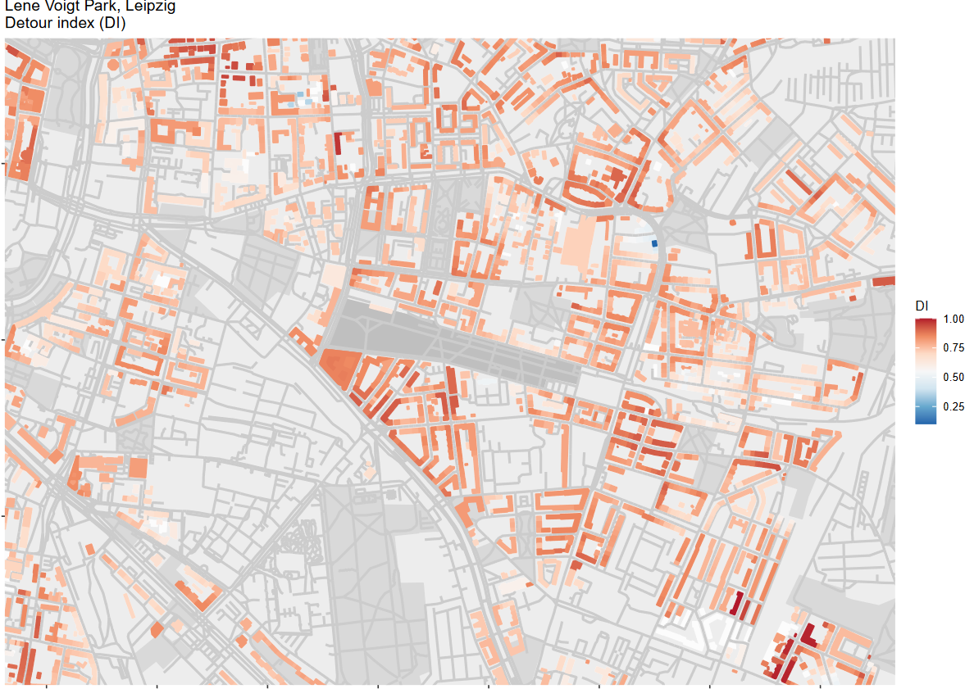

*Figure 3: The building colors represent average Detour Index values (DI) calculated for all green spaces in a network distance of 500 meters from a building. The dark blue the color of a building is, the closer to one the DI value, the more direct can its residents travel to the closest green spaces. The opposite is the case if the color tends towards orange.*

* + - We can make out lower LS values at streets with residential buildings that are close to the threshold of 500 meters distance to the nearest green space.
    - E.g. in the southeast of the map, in many streets, the blue shade is getting brighter with each street segment until it switches over to red shades.
    - With each building entry, more inhabitants are expected to take these routes towards the nearest green space.
    - This increases the LS values of the street segments.
    - Figure X displays the detour index (DI) east of the city center of Leipzig.
    - Again, higher values are depicted in red shades, lower ones in blue shades.
    - High DI values can be found at buildings that are located at streets which lead directly to a green space entry.
    - Along these streets there are straight formations of buildings with high DI values as can be seen in the south of the LVP.
    - In contrast, there occur clusters of low DI values in areas where larger detours have to be taken to reach a park entry. Such areas can be found in the northeast of the map.
    - Furthermore, we can observe low DI values at buildings that are close to several or directly adjacent to one green space.

**2. Comparing walkability indices**

MW: Ich glaube hier könnte/müsste man nochmal eine Erläuterung einfügen. Vielleicht sogar nochmal kurz die karte vom LVP und dazu die DI Kurve – dann hat jeder ne vorstellung Davon was hier gleich kommt

* Europe comparison
  + Spatial clustering DI
    - In figure x (DI MAP) we can observe a clustering of cities with mid- to high shares of population with DI values above 0.8 in northern and central European countries.
    - This cluster consists especially of cities in the Netherlands, Belgium, Luxemburg and Germany, as well as the western parts of Poland and the Czech Republic.
    - These cities also exhibit mostly high DI coverage, i.e. share of people with access to green spaces in 500 meters network distance or less.
    - In France, the UK, Italy and the eastern part of Poland, we see a larger share of cities with a lower DI coverage.
    - In these countries we also see a larger variety of the percentage of population with DI values greater than 0.8.
    - As we can see in figur­­­­e x, the distribution of DI values plotted against population varies strongly across countries.
    - The ending points of the lines show the percentage of people with green spaces in a network distance of 500 meters.
    - The slopes of the lines show how direct the inhabitants of a country can travel to the green spaces they have access to.
    - On the top end there are mostly northern and central European countries like Finland, Sweden and Luxembourg where more than 85% of the urban population can reach green spaces in 500 meters network distance.
    - On the lower end there are southern and south eastern European countries like Albania, Kosovo, Serbia and Romania.
    - In these countries, 30% of the population or less live in 500 meters network distance of green spaces.
    - It is notable, though, that on both ends of the spectrum, the sample size is limited to only a few cities (top: FI = 3, SE = 5, LU = 1, bottom: AL = 2, XK = 1, RS = 3, RO = 5).
    - Yet, there are countries with large city samples and a high percentage of population reaching green spaces in 500 meters network distance, like Germany (126 cities, 73%) or Poland (68 cities, 69%).
    - Additionally, there are countries with large city samples and a lower percentage of people in proximity to green spaces like France (84 cities, 58%) and Italy (56 cities, 57%).

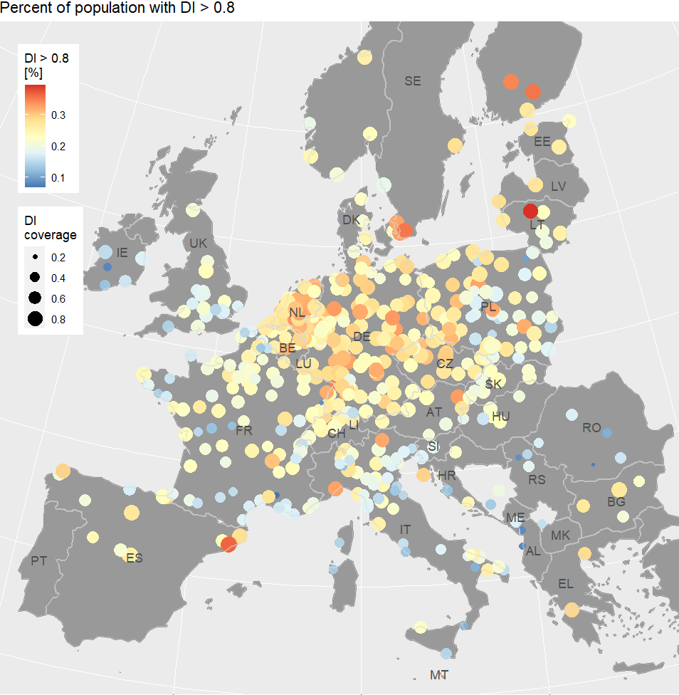

Figure Top: share of population with DI values of 0.8 or greater (in cities with OSM coverage > 85%). Bottom: DI values per share of population.

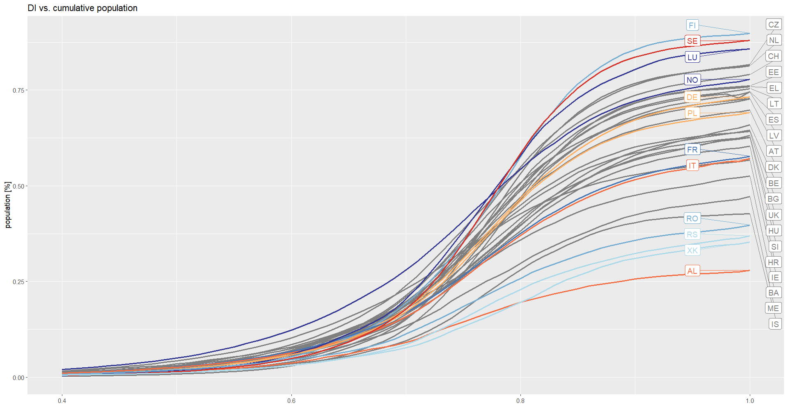

* + - Generally, a curve that has a late onset and a steep slope means that more people have a more direct route to the nearest green spaces and vice versa.
    - An example for this would be Finland, where about 32% of the urban population have an DI of more than 0.8.
    - On the contrary, the curve of Norway has an early onset and a lower ending point, resulting in a smaller share of people (23%) having a DI in the highest 0.2 margin.
  + Spatial clustering LS
    - The average LS values at green space entry of the European cities also show a large variation.
    - In figure X (LS MAP) we can for example observe relatively high average LS values at the green space entries in mid- to southwestern Germany.
    - In contrast, most of the cities in France or at the eastern coast of Italy feature rather low LS values.
    - In Poland or the Netherlands, we find a mixed picture of cities with higher and lower LS values at green space entry.
    - In figure x we see the LS values aggregated on a country level.

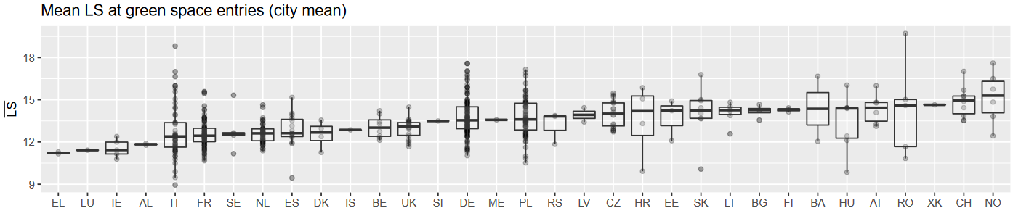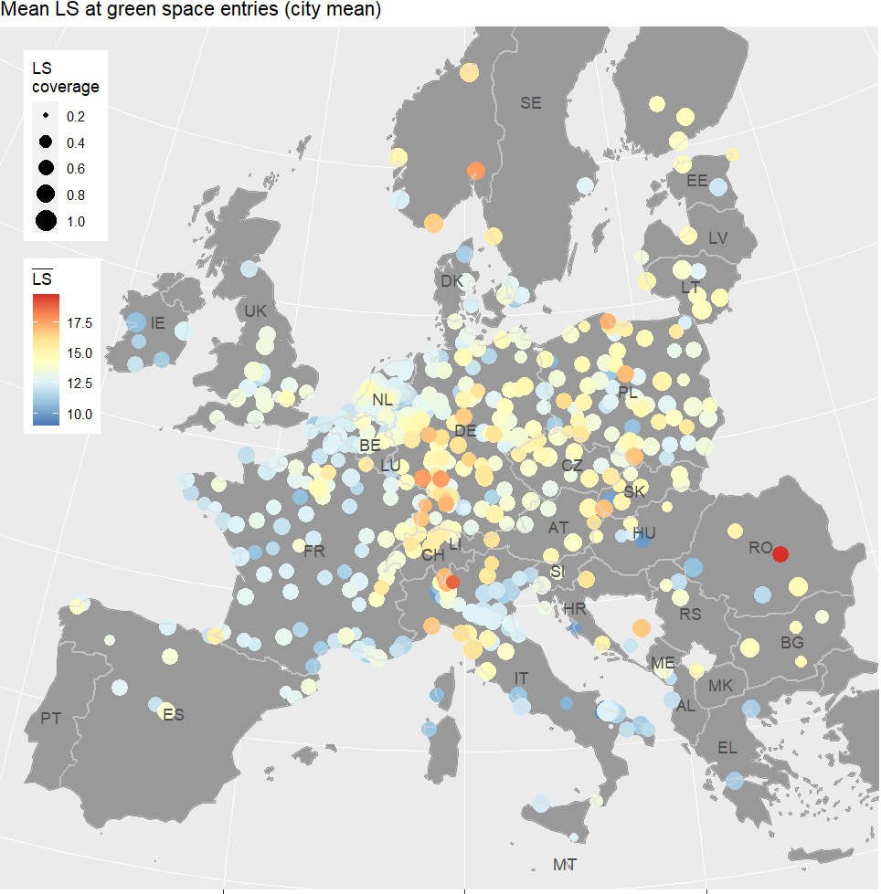

Figure (top): Mean LS at green space entry points per city (color) and LS coverage – i.e. percent green spaces in a city that have been reached by inhabitants (size). (bottom): Mean LS values at green space entry points per city. Aggregated by country.

* + - Every point that is plotted behind the box-plots represents the average LS value at green space entry of one city.
    - Accordingly, we see that the differences in the number of cities where our analysis was feasible vary substantially between countries.
    - At the bottom and top ends of the chart, there are countries where relatively few cities are included in the final analysis, like Greece, Luxembourg or Norway.
    - From the countries with a larger share of cities that were eligible for our analysis, Italy has the largest spread of LS values and the Netherlands the smallest.

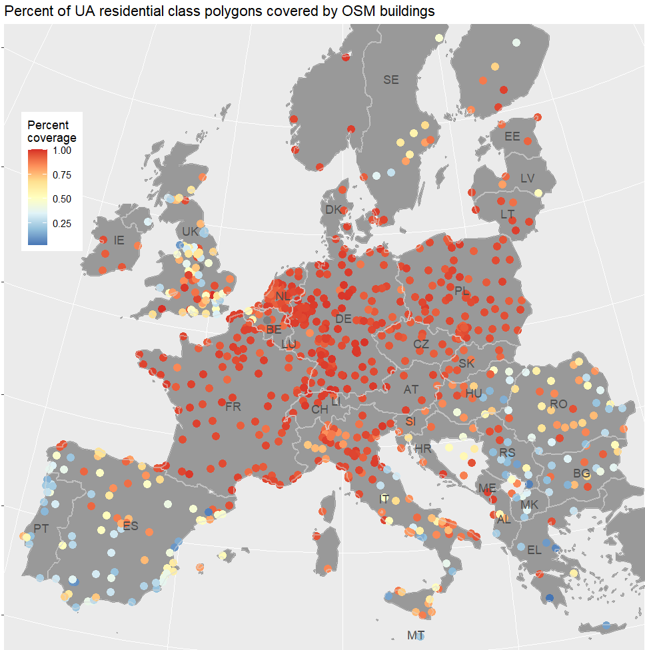

Figure Percentage of urban atlas residential class polygons that contain at least one OpenStreetMap building polygon. Red colors represent a higher coverage. Yellow and blue colors represent lower share of covered polygons.

* Results of Objective 1
  + Figure x depicts the OSM coverage, i.e. the relative share of UA polygons that are covered by at least one OSM building polygon.
  + Most cities in central Europe exhibit a very high OSM coverage of nearly 100 percent.
  + In the UK, northern Spain and the southeast of Europe, we see more cities with an OSM coverage of less than 50%.
  + In Portugal and the south of Spain, OSM coverage is even lower, with few cities above 50% OSM coverage.
  + The city of Leipzig that we used for developing the different scenarios in the previous chapter was a prime example of a city with very high OSM coverage.
  + In Leipzig about 93% of the UA polygons are covered by at least one OSM building.
  + As we see in figure …a, most of the low coverage can be explained by a lacking digitalization of buildings in the OSM dataset.
  + One source of error explaining a fraction the imperfect coverage in most cities are misclassified UA polygons (see Appendix 1b).
  + In another share of UA polygons, the population values might have been so small that none of the OSM buildings received a population count, so they got filtered out during the data cleaning process (see Appendix 2b).
  + In figure x we see two exemplary cities – Vienna as an example for a high OSM coverage and Lisbon as an example for a low OSM coverage.
  + The city of Vienna, Austria has an OSM coverage of 98.7%, while in Lisbon, Portugal 55.6% of the UA polygons are covered by OSM buildings.
  + The OSM building coverage in Lisbon is declining with higher distance from the city center.
  + Where OSM buildings are present, the generation of LS and DI indices worked.
  + Large parts of the residential areas of both cities have no OSM coverage and, thus did not get index values.
  + This would result in unreliable estimates of DI values per population, because a large share of the inhabitants would be assigned a DI value of 0.
  + Also, comparing the LS values could prove unreliable, even though we use the average value at green space entry for the above analysis.
  + Missing residential buildings in the service area of green spaces would lead to LS values that might be lower than expected.
  + Due to these inconsistencies, we decided to exclude all cities with an OSM coverage of less than 85% from the above analysis.
  + Most of Europe’s capital cities feature a high OSM coverage and by choosing a threshold of 85%, we only had to exclude 5 of them from our analysis (Lisbon, Athens, Budapest, London and Madrid).

**3. Implement walkability indices**

MW: For demonstrating how local planners can use the applied indicators for walkability, we will explore three potential alternatives in reshaping the built-environment as an expression of applied planning tools. Therefore, we return to the example of LVP as outlined in section X.1. In each alternative, one of the core proxies used for calculating LS and DI is varied: In a first alternative “unlimited access” it is assumed that accessing the park is possible from all around. In a second alternative “densification” a selected number of alternative UGS north of LVP is sealed and turned into residential houses. A third alternative applies “population growth” to each of the buildings.

Daggi: Ich würde nicht von Szenarien sprechen, denn wir machen ja keine komplexen Änderungen, daher lasst uns lieber von alternatives sprechen, ja?

* Scenario 1 – Unlimited access

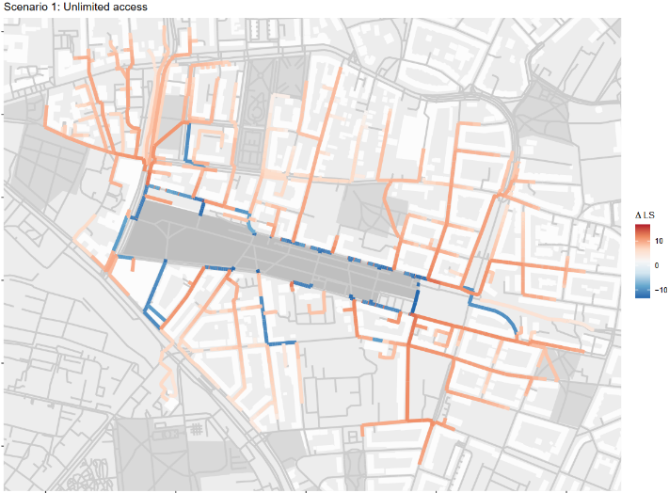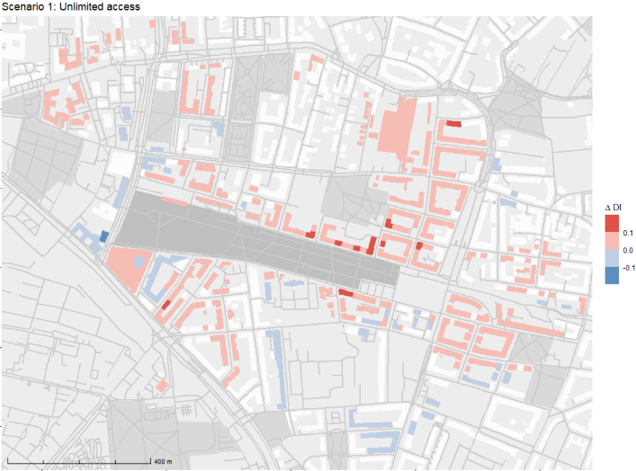

Figure Delta values for local significance (left) and detour index (right). Streets and buildings that expressed no change are not colored. Increase is mapped in red, decrease in blue. The top two map show the unlimited access scenario.

* + In the first scenario we demonstrated how the LS and DI indicators would change if all barriers obstructing access to the Lene-Voigt-Park (LVP) were to be removed.
  + We did so by assuming a park entry every 5 m on the network surrounding Lene-Voigt-Park.
  + As can be seen in figure x_a, a decrease in LS values occurs on all streets that are adjacent to the LVP.
  + On most of the remaining streets, we observe an increase in LS.
  + Thus, according to our model, removing the barriers along the edges of the LVP would, result in less crowded streets surrounding the park.
  + On the other hand, more people could reach the LVP, increasing the overall amount of people traveling through net network.
  + Figure x_b shows the change of the DI values in the first scenario.
  + Overall, we mostly observe minor changes of DI values (delta-DI < 0.1).
  + We filtered out any delta-DI values that were below 0.05 to place emphasis on the more significant changes.
  + It appears as though the change of DI values is mostly limited to buildings that are either very close to the park or that are now inside the threshold network distance.
  + A few buildings adjacent to the eastern part of the LVP express an increase larger than 10%.
  + A larger area to the northeast and smaller areas to the east and south of the center of the LVP show a minor increase of DI values.
  + These buildings may now be able to take a more efficient trajectory towards the LVP.
  + In the northwest of the map we see a cluster of buildings that seems to have gained access to the LVP via a direct path, which increased their DI values.
  + Contrary, in the southeast there is a couple of buildings that have gained access as well, but on a less direct path.
  + For these buildings the DI values decreases.

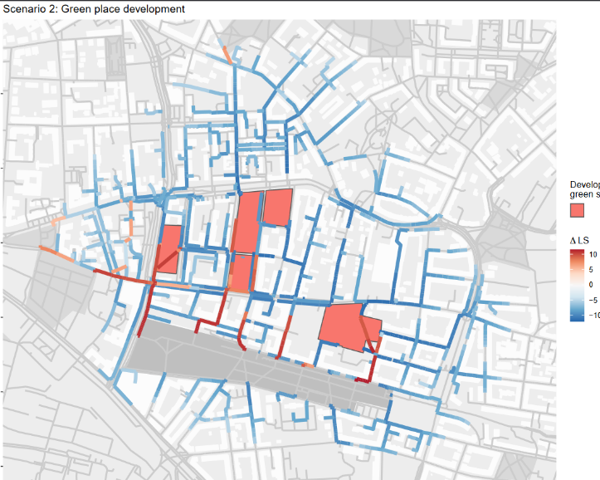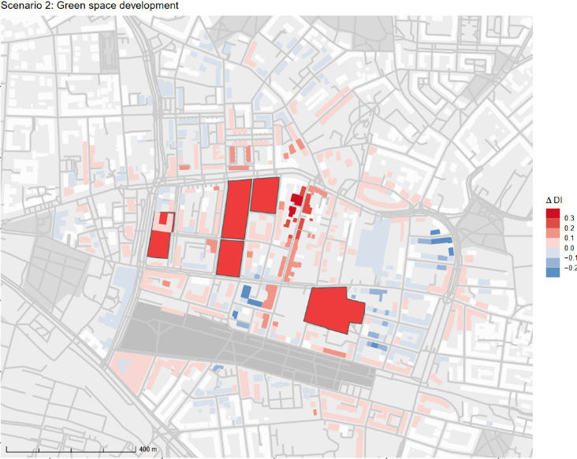

* Scenario 2 – Green space development
  + In the second scenario we intended to see how the indices behave if the green spaces in the city blocks north of the LVP were to be developed into residential areas.
  + To apply these changes, we switched the former park entries into building entries and distributed among them population according to the former park’s size.
  + Figure x-c shows that overall, most of the LS values appear to decrease substantially.
  + Only on the paths connecting the newly built residential areas to the LVP and the former *Johannes-cemetery* in the west can we see a substantial increase of LS values.
  + The reduction of the number of parks in the area seems to have a larger effect on the LS-index than the increase in population.
  + In Figure X-d we see DI values mostly increasing in the area.
  + Especially the buildings along the *Heinrichstraße* that leads from the center of the LVP north experience a substantial DI increase.
  + Some areas in the east and north of the map express a decrease of DI values.
  + South and west of the LVP we observe a mixed picture of minor de- and increases.
  + The five green spaces that we intended to develop are rather small and, thus, hard to reach.
  + Taking them out of the equation seems to leave the surrounding buildings with more efficient trajectories towards the larger parks.
* Scenario 3 – Population increase
  + The third scenario is designed to demonstrate how a population increase would affect the DI and LS indices.
  + In this scenario, we assumed for each residential building a population increase to the 95th percentile of the population per area according to its urban atlas residential class.
  + Since we did not change the locations of any green space or building entries, the DI index did not change, either.
  + 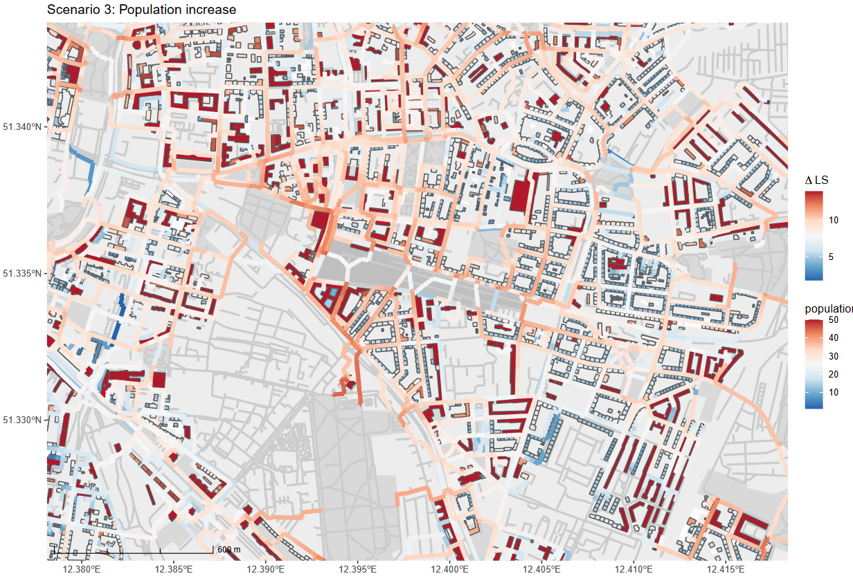As we can see in figure x, the delta-LS is positive in the entire area, so the colors are to be interpreted as in the basic map without changes.
  + In this scenario, we see a similar pattern as in the basic LS map (see figure x).
  + LS tends to grow larger, the closer a street is to one of the large parks.
  + Here, we can observe the highest values between the LVP and the Friedenspark in the south of LVP.
  + The further away a street is from the larger parks, the lower the increase of the LS.
  + Close to LVP the area with the highest values is now in the west, instead of in the east as in the base scenario.
  + If we have a look at the population data that is attached to the residential buildings, we can see that the area in the northwest of the LVP has several buildings with very high population.
  + Most of these buildings can reach the LVP only via the entry point at the northwest, which causes the high LS values in this area.
* Scenario 4 – Ensemble model
  + In the final scenario, we applied all the changes of the previous three scenarios at once.
  + The joint effects of removing barriers, developing the green space in the north and a population increase can be seen in figures x a and b.
  + Figure x a, shows that the change of the LS index is mostly influenced by the population increase and the green space development scenarios.
  + Due to the population increase scenario, we see a general increase of LS, except for those streets that experience a decrease of LS due to the removed green spaces.
  + Similar to the population increase scenario, we see a large area with high LS increase in the northwest of the LVP.
  + In this scenario we can simultaneously observe the effects of the population increase and the unlimited access scenarios.
  + The nearest entry point of area with the high population residential buildings in the northwest has been shifted to the northernmost corner of the LVP in contrast to the third scenario.
  + As we can observe in figure x b, change of DI is restricted to those buildings that either reached one of the now developed green spaces before or that can reach the LVP through one of the new entry points.

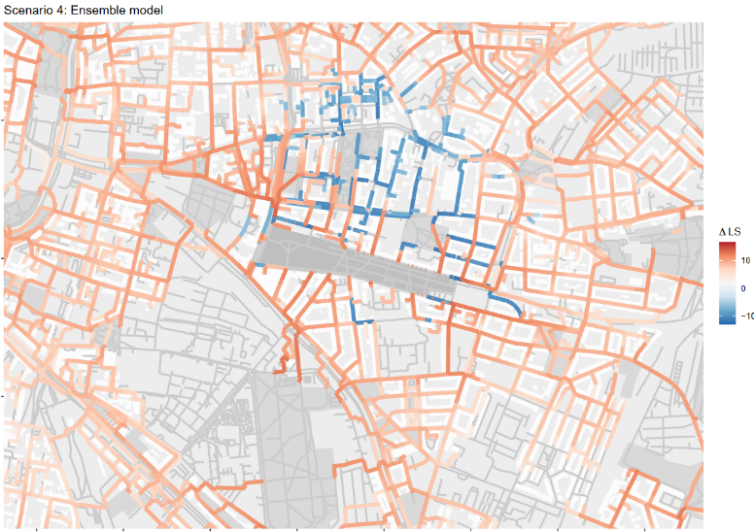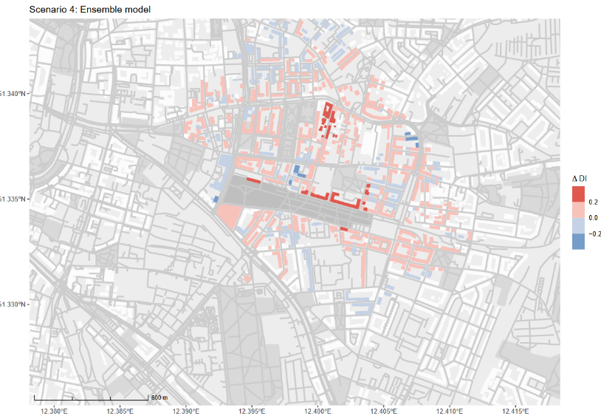

* + In the fourth scenario we can still see an overall increase in DI from removing the small and hard-to-reach green space in the north of the LVP.
  + Also, the mixed effects from removing the entry barriers to the LVP can still be observed in the south or the northwest of the LVP.